**LEBANESE AMERICAN UNIVERSITY**

**USAID – HIGHER EDUCATION SCHOLARSHIP PROGRAM**

**HES - Volunteering Program Verification Form**

This form is to be used to document volunteering hours. If a student volunteers for multiple organizations, a separate form must be used for each organization. **This form must be turned in by the 28th of each month, the latest.**

I certify that the scholar Ghina Bou Kamel completed a total of 5 hours of service at InnovaThrive.

The hours were completed hours as per the below:

Hours # 0 (date) _2/12 – 6/12_ (initials of supervisor) __A.K.___

Hours # 0 (date) _9/12 – 13/12_ (initials of supervisor) __A.K.___

Hours # 0 date) _16/12 – 20/12 (initials of supervisor) __A.K.___

Hours # 5 date) _23/12 - 27/12 (initials of supervisor) __A.K.___

Brief description of the activities the scholar performed or participated in:

I have researched the Social Learning Theory (Albert Bandura)  
particularly its Practical Application in Therapy I foccused on Modeling Behavior in Therapy, media and Behavior and criticisms of the theory.

Written feedback about the scholar’s performance:

Ghina Bou Kamel’s research on Social Learning Theory and its application in therapy was thorough and well-articulated. By focusing on modeling behavior and media influences, Ghina demonstrated a deep understanding of Albert Bandura’s work and its practical implications. Her critical analysis of the theory’s strengths and limitations added depth to the research.

Please rate the overall performance of the scholar at your organization:

|  |  |  |  |
| --- | --- | --- | --- |
|  | Mastery (5) | Proficient (3) | Emerging (1) |
| **Problem solver** | X |  |  |
| **Engaged & Committed** | X |  |  |
| **Open-minded & multicultural** | X |  |  |

Signature

& stamp

__________________________

_

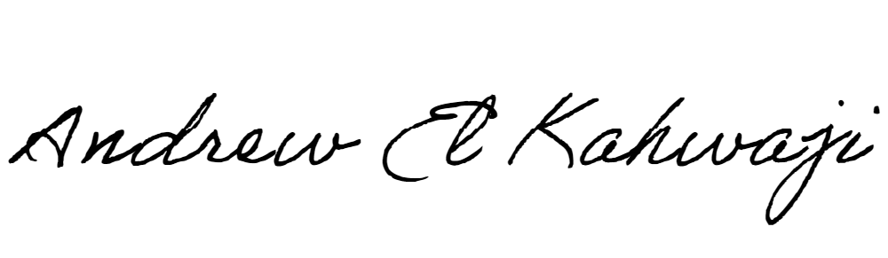

Printed Name _Andrew El Kahwaji_

Date __26/12/2024___

Email __andrew.lifesculptor.coo@gmail.com __

Phone __+961 71 914 378__